**Name: Laiba Gul**

**SapID:55740**

**Class: BSCS(7th)**

**Lab: 07**

**Question no:01**

**Code:**

.model small

.stack 100h

.data

.code

main proc

mov ah, 1

int 21h

sub al, 48

mov bl, al

mov al, bl

mul bl

mov bh, ah

mov bl, al

mov ah, 2

mov dl, 13

int 21h

mov dl, 10

int 21h

add bh, 48

mov dl, bh

mov ah, 2

int 21h

add bl, 48

mov dl, bl

mov ah, 2

int 21h

mov ah, 4ch

int 21h

main endp

end main

**Output:**

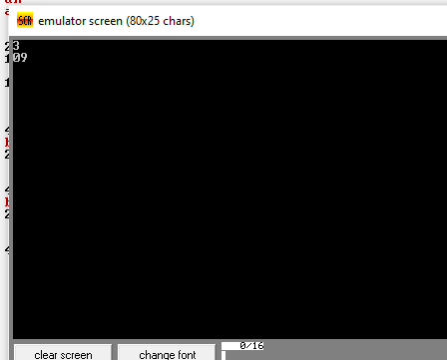

**Question no:02**

**Code:**

org 100h

.model small

.stack 100h

.data

msg db 'Enter a number: $'

resultMsg db 0Dh, 0Ah, 'The cube is: $'

number db ?

cubed db ?

.code

main proc

mov ax, @data

mov ds, ax

mov dx, offset msg

mov ah, 09h

int 21h

mov ah, 01h

int 21h

sub al, 48

mov number, al

mov al, number

mul al

mov bl, al

mov al, number

mul bl

aam

mov dx, offset resultMsg

mov ah, 09h

int 21h

add ah, 48

mov dl, ah

mov ah, 02h

int 21h

add al, 48

mov dl, al

mov ah, 02h

int 21h

mov ah, 4ch

int 21h

main endp

end main

**Output:**

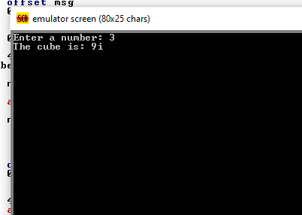

**Question no:03**

**Code:**

.model small

.stack 100h

.data

msg1 db 'Enter first number: $'

msg2 db 'Enter second number: $'

result_msg db 'The result is: $'

num1 db 0

num2 db 0

result dw 0

.code

main:

mov ax, @data

mov ds, ax

mov ah, 09h

lea dx, msg1

int 21h

mov ah, 01h

int 21h

mov al, bl

mov ah, 0

mul cl

sub al, 30h

mov bl, al

mov ah, 09h

lea dx, msg2

int 21h

mov ah, 01h

int 21h

sub al, 30h

mov cl, al

mov result, ax

mov ah, 09h

lea dx, result_msg

int 21h

mov ax, result

call PrintNumber

mov ah, 4Ch

int 21h

PrintNumber proc

mov bx, 10

xor dx, dx

div bx

add dl, 30h

mov ah, 02h

int 21h

endp

end main

**Output:**

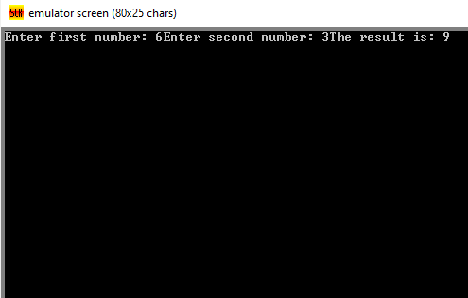

**Question no:04**

**Code:**

.model small

.stack 100h

.data

prompt_base db "Enter base of the triangle: $"

prompt_height db "Enter height of the triangle: $"

result_msg db "The area of the triangle is: $"

newline db 0x0A, 0x0D, '$'

.code

main:

mov ax, @data

mov ds, ax

mov ah, 09h

lea dx, prompt_base

int 21h

mov ah, 01h

int 21h

sub al, '0'

mov bl, al

mov ah, 09h

lea dx, prompt_height

int 21h

mov ah, 01h

int 21h

sub al, '0'

mov cl, al

mov al, bl

mov ah, 00h

mul cl

shr ax, 1

mov ah, 09h

lea dx, result_msg

int 21h

add ax, '0'

mov dl, al

mov ah, 02h

int 21h

mov ah, 09h

lea dx, newline

int 21h

mov ah, 4Ch

int 21h

end main

**Output:**

